PMT Amplifier

Karel Svoboda  
Group Leader

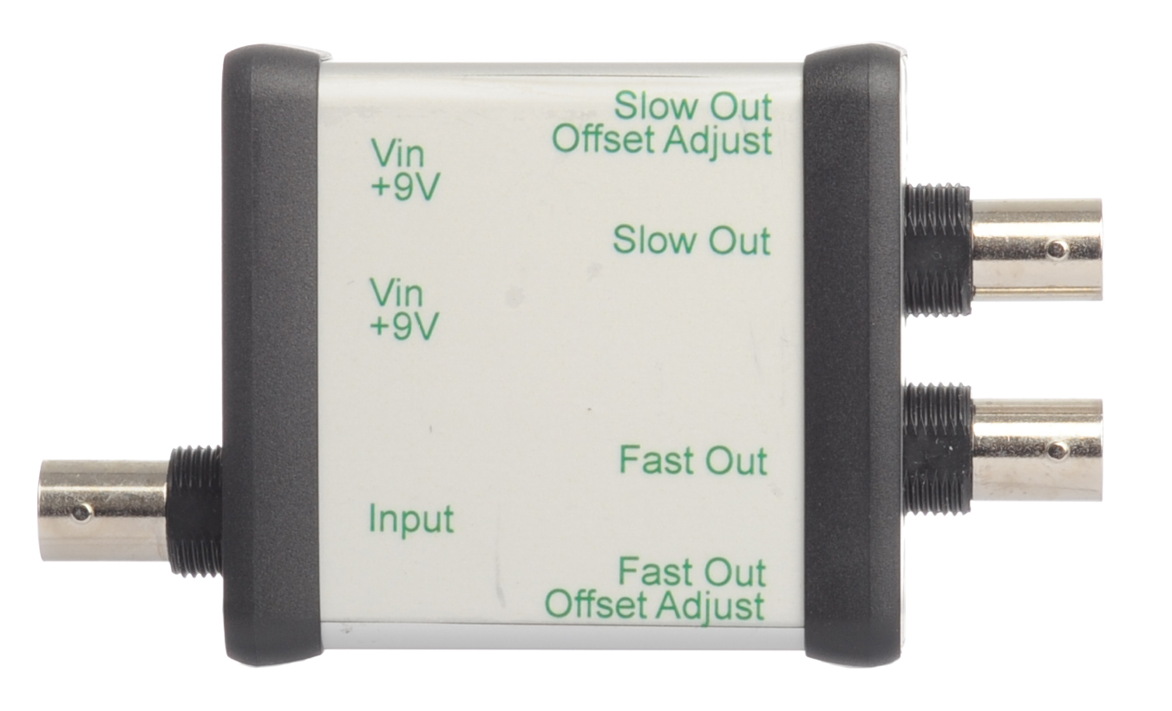

**3/27/2012**

Samantha Watkins  
Engineering Specialist, ID&F  
(571) 209-4371

# System Overview

The PMT Amplifier will be used as an error detector with microscope use. There will be fast and slow output. The fast output is the input signal from the PMT, but amplified with some filtering. The slow output will take the fast output and apply a low-pass filter with a 1 kHz roll off. The slow output will be an indicator of too long of a light exposure to the PMT, therefore the sensitive equipment, and will create a safety shutdown.

# Hardware Development

*Materials*



# Testing

The PMT Amplifier can be tested with a signal generator when RIN is replaced with a high value resistor. A PMT can also be used to test the Amplifier when a 0Ω resistor is used for RIN. The fast output should display a light pulse from the PMT and the slow output should give a low pass response when the PMT is exposed to too much light.

## Board Configurations

### R1: OPA657-OPA692-OP400

|  |  |
| --- | --- |
| **Stage 1: OPA657** |  |
| Transimpedance Gain | 20 kΩ |
| Feedback Capacitor | 0.4 pF |
| **Stage 2: OPA692** |  |
| Gain | 2 |
| Pulse Duration | 40 ns |
| Output Voltage Offset Adjust | Disabled. Pin grounded to allow for int. gain of 2 |
| **Stage 3: OP400** |  |
| Gain | 1 |
| Filter Cutoff – Freq Response | 1.6 kHz |
| Output Voltage Offset Adjust | Enabled |

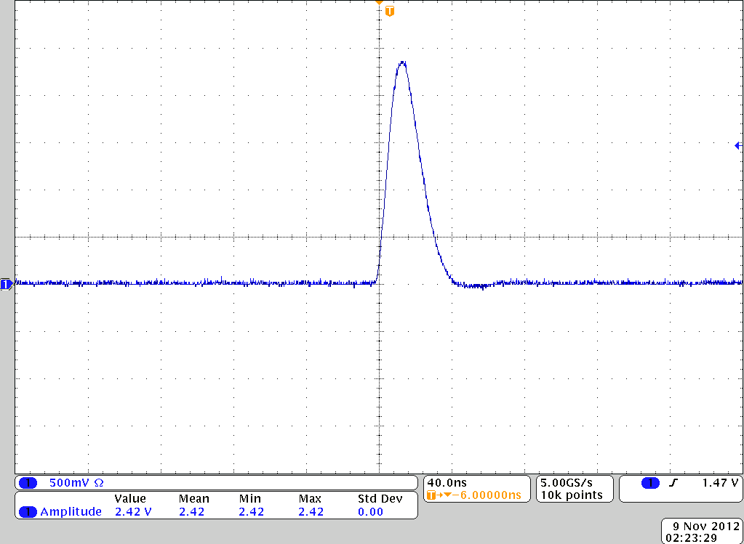**Fast Output from Stage 2: OPA657-OPA692-OP400**

### R1: OPA657-AD810-OP400

|  |  |
| --- | --- |
| **Stage 1: OPA656** |  |
| Transimpedance Gain | 100 kΩ |
| Feedback Capacitor | 0.5 pF |
| **Stage 2: AD810** |  |
| Gain | 2 |
| Pulse Duration | 250 ns |
| Output Voltage Offset Adjust | Enabled |
| **Stage 3: OP400** |  |
| Gain | 1 |
| Filter Cutoff – Freq Response | 1.6 kHz |
| Output Voltage Offset Adjust | Enabled |

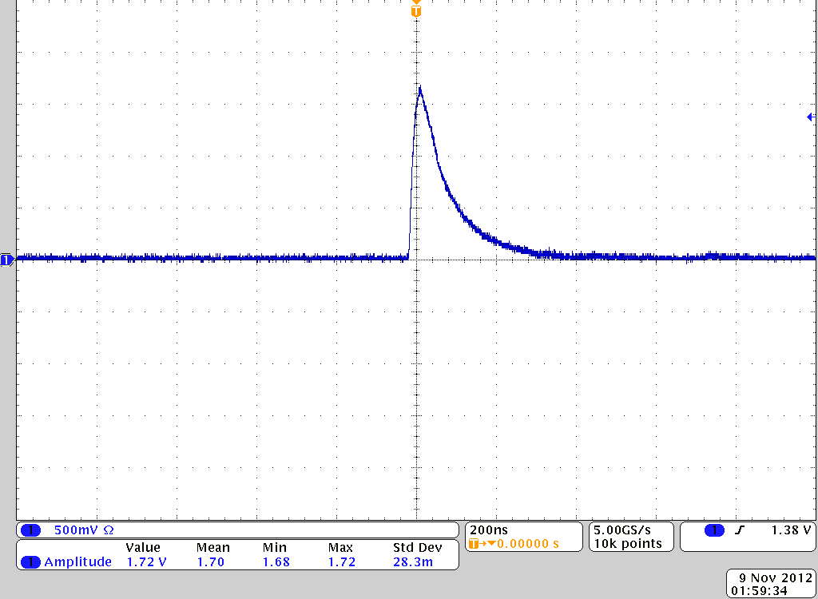**Fast Output from Stage 2: OPA657-AD810-OP400**

### R1: OPA656-AD810-OP400

|  |  |
| --- | --- |
| **Stage 1: OPA656** |  |
| Transimpedance Gain | 100 kΩ |
| Feedback Capacitor | 0.4 pF |
| **Stage 2: AD810** |  |
| Gain | 2 |
| Pulse Duration | 180 ns |
| Output Voltage Offset Adjust | Enabled |
| **Stage 3: OP400** |  |
| Gain | 1 |
| Filter Cutoff – Freq Response | 1.6 kHz |
| Output Voltage Offset Adjust | Enabled |

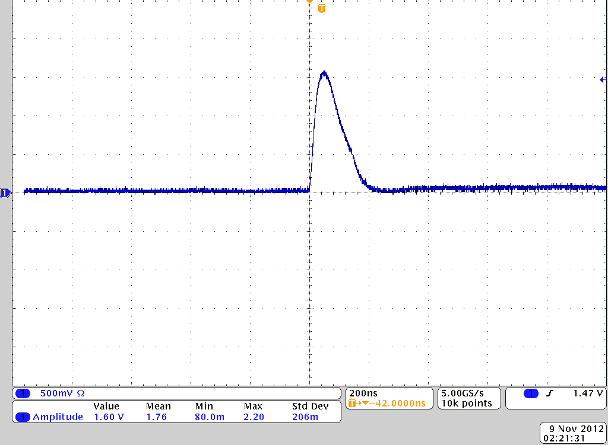**Fast Output from Stage 2: OPA656-AD810-OP400**

### R1: OPA657-BUF634-OP400

|  |  |
| --- | --- |
| **Stage 1: OPA657** |  |
| Transimpedance Gain | 100 kΩ |
| Feedback Capacitor | 0.4 pF |
| **Stage 2: BUF634** |  |
| Gain | 1 |
| Pulse Duration | 320 ns |
| Output Voltage Offset Adjust | Disabled |
| **Stage 3: OP400** |  |
| Gain | 1 |
| Filter Cutoff – Freq Response | 1.6 kHz |
| Output Voltage Offset Adjust | Disabled |

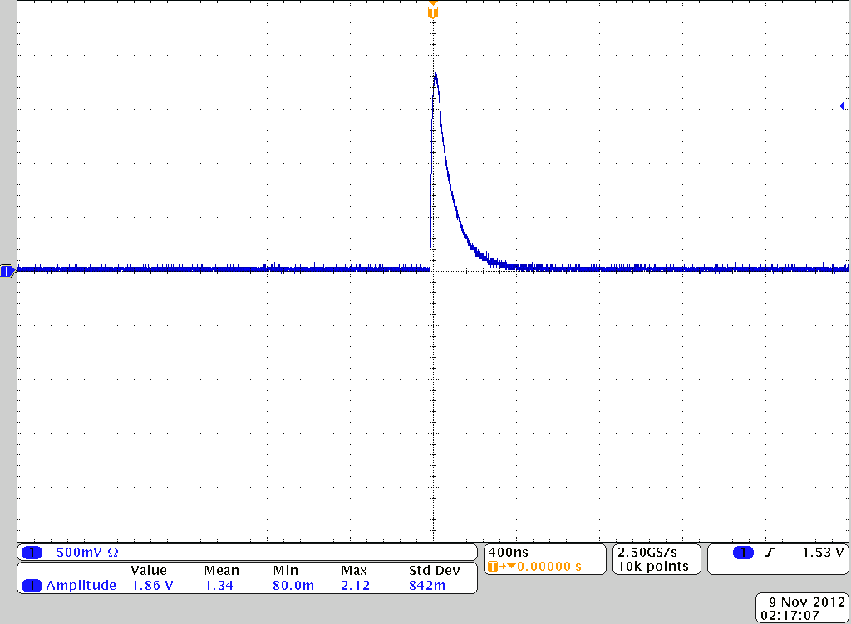**Fast Output from Stage 2: OPA657-BUF634-OP400**

## Frequency and Gain Analysis

|  |  |  |  |  |  |
| --- | --- | --- | --- | --- | --- |
| **Freqin (@1V,20kΩ)** | | **Gain** | | | |
| **OPA657 OPA692** | **OPA657 AD810** | **OPA656 AD810** | **OPA657 BUF634** |
| 50kHz | 5.00E+04 | 7.4 | 5.72 | 5.76 | 6.4 |
| 100kHz | 1.00E+05 | 7.4 | 5.72 | 5.76 | 6.4 |
| 250kHz | 2.50E+05 | 7.4 | 5.72 | 5.76 | 6.4 |
| 500kHz | 5.00E+05 | 7.4 | 5.72 | 5.76 | 6.36 |
| 1MHz | 1.00E+06 | 7.36 | 5.56 | 5.64 | 6.36 |
| 2MHz | 2.00E+06 | 7.4 | 5.56 | 5.64 | 6.36 |
| 5MHz | 5.00E+06 | 7.4 | 5.2 | 5.32 | 6.36 |
| 10MHz | 1.00E+07 | 7.4 | 4.84 | 5 | 5.08 |
| 25MHz | 2.50E+07 | 7.2 | 3.32 | 3.64 | 2.2 |
| 50MHz | 5.00E+07 | 7.2 | 1.28 | 1.72 | 0.044 |
| 70MHz | 7.00E+07 | 6.8 |  | 1.24 | 0.056 |
| 80MHz | 8.00E+07 | 6.4 |  | 1 |  |
| 85MHz | 8.50E+07 | 6.1 |  |  |  |
| 90MHz | 9.00E+07 | 5.3 |  |  |  |
| 95MHz | 9.50E+07 | 4.8 |  |  |  |
| 100MHz | 1.00E+08 | 4.4 |  |  |  |
| 105MHz | 1.05E+08 | 3.96 |  |  |  |
| 110MHz | 1.10E+08 | 3.72 |  |  |  |

# Sample Circuit Set-Up

### R1: OPA656-AD810-OP400

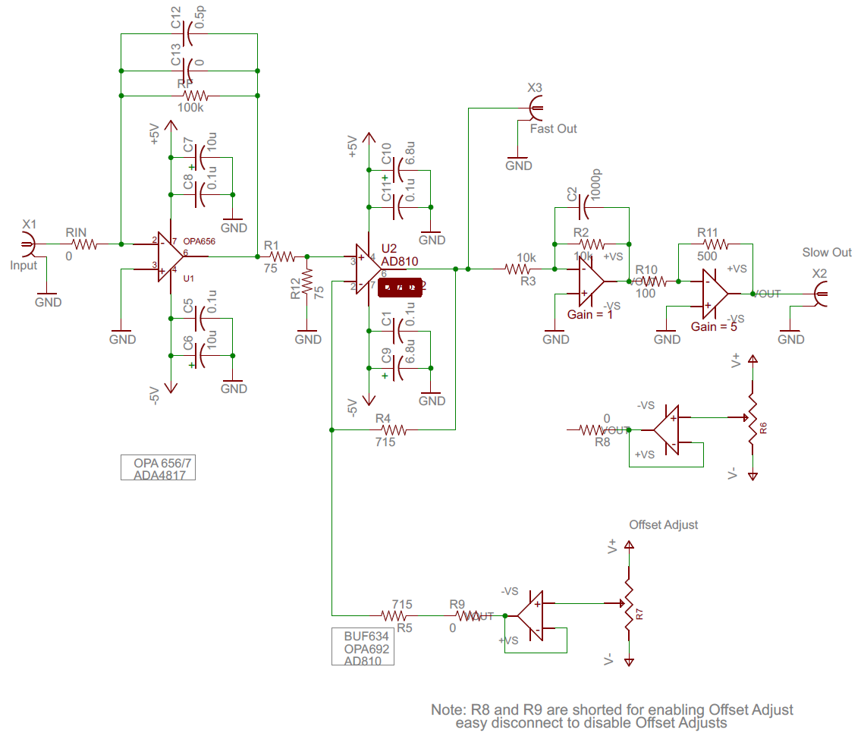

### R1: OPA657-BUF634-OP400

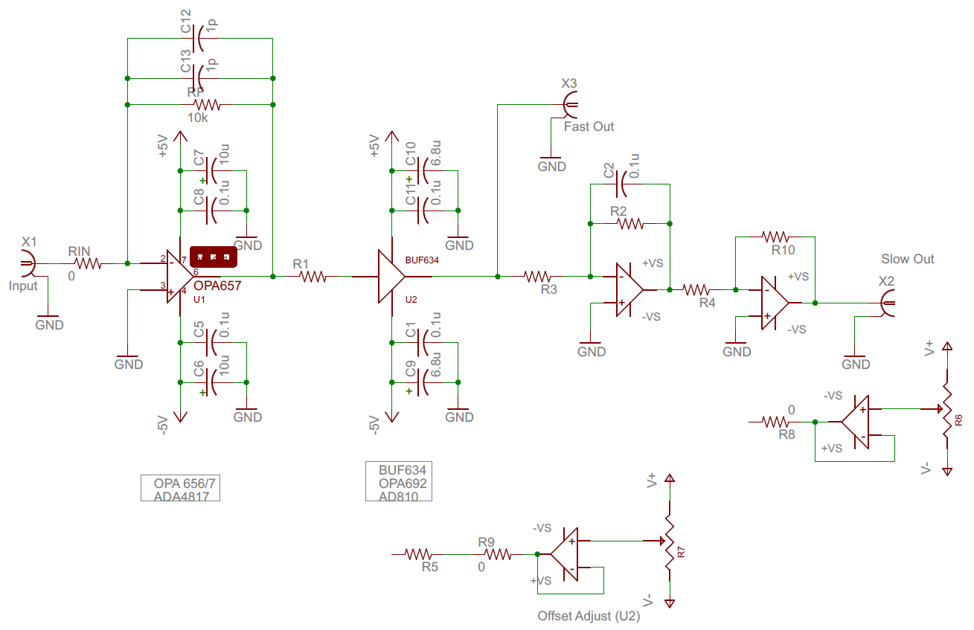

# Appendix

Assembly Note: R1 and Amp1 marked on the boards are the same, only differing in physical changes. Amp1 is the latest rendition in Vault as Revision B.

